Chicago’s Abandoned Cars

**Abstract**

The purpose of this study is to examine the problem of abandoned cars. This paper characterizes abandoned vehicles, characterizes their locations, and models the city’s response.

The data was modified by removing the 16,000 values marked as duplicates, and entering 0 for all days parked with unlikely values greater than 1000 and negatives, 0 for unknown wards transit score, and 0 for makes that are trailers, motorcycles, or unknown. The analysis was performed on a sample size of 63,386 vehicles reported as abandoned in the city of Chicago since 2013.

This analysis has shown that most abandoned vehicles are from Illinois or unlisted state, are domestic makes, and painted the common colors white, gray, black, silver, and red. The vehicles are likely to be older models, and left on side streets in areas with poor access to public transportation. The average complaint takes 19.7 days to resolve with a standard deviation of 17.9, and citizens are waiting more than a month to call in the complaints to 311. Chi-squared tests show a relationship between the type of manufacturer and color, and between the manufacturer and the ward’s access to public transportation. However, no relationship is shown between out of state vehicles and where they are parked. The city is more likely to resolve complaints in less than three weeks if the vehicles are parked downtown. Other factors that predict city response are whether the license plates are registered out of state and whether the maker is domestic, Asian, European, or unknown. A Poisson model provides the best fit, forming the equation predicting whether city response time would be greater than 3 weeks log(response) = -0.96 – 0.32 (Out of State) – 0.06 (Main Thoroughfare) + 0.05 (Maker). Therefore, the city appears unbiased in addressing wards with poor access to public transportation and vehicles of uncommon color.

Future studies could glean additional insight by examining duplicates and comparing Chicago’s response to that of its suburbs. Programs to help people pay for car repairs or improve public transit options could help limit this problem.

**Introduction**

A car is considered by many to be a necessary asset in the sprawling United States. A personal vehicle can offer protection against weather or crime, reduce commute time, move bulky items, transport children, allow access to more distant areas for employment or recreation, and represent status. However, in some unfortunate cases, cars are left on public streets in a state or duration that causes concern for neighbors.

The purpose of this study is to examine the problem of abandoned cars. This paper characterizes abandoned vehicles, characterizes their locations, and models the city’s response.

**Background**

As Lutz writes on page 235 of her analysis of how car dependence exacerbates inequality between social classes, “substantial expenses incurred in most households to own and operate a car are often underestimated by those who bear them given how many different types of expense there are. They include the cost of the car itself and its loan financing; gasoline, insurance, and parking costs; registration and other government fees and taxes; and repair expenses” [1]. Yet, her low income interview subjects see car ownership as both a necessity and a source of pride,

even as they struggle to balance these myriad costs with the need to pay rent and purchase food on a tight budget. Lutz highlights several cases of people delaying repairs or registration because they are unable to afford them.

Drivers with lower incomes are more likely to purchase used vehicles or drive them for a longer period. A 2009 article in Consumer Reports indicates that the quality of used cars was improving, with Asian cars, in particular Honda and Toyota, showing the greatest reliability, and European cars being among the least reliable [2]. Nieuwenhuis argues that used cars should have extended lifetimes to promote environmental sustainability, and that too many roadworthy or easily repairable vehicles are scrapped. He suggests that cars are capable of duration far greater than we expect with careful maintenance and emotional attachment, and highlights the fact that cars older than 20 years old (considered classics) are not limited to high income owners [3]. He is against programs for increasing scrap cost that disincentivize long-term ownership.

In contrast, Forslind proposes a deposit-refund system to promote return of vehicles to recycling facilities to decrease the environmental impact of their languishing on city streets [4]. In cases of high environmental impact, she also advocates assistance from law enforcement in penalizing the owners. The vehicles may leak fluids, leach metals, or pose a physical hazard due to broken glass. Therefore, Forslind would be likely to disagree with Nieuwenhuis on incentives. Fortunately for this approach, scrap prices did increase in the early 1990s, driven by the steel industry’s growing reliance on recycled feedstock and causing the volume of abandoned cars to decrease in past decades [5].

With the greater reliability of used cars, higher scrap prices, and necessity of vehicle ownership for many, the problem of abandoned vehicles has abated. However, thousands of vehicles are still reported every year, so it remains a significant drain on city resources. Possible causes include arrest, disrepair, lack of money for registration, traffic accident, for sale sign, stolen property, or illness.

The City of Chicago Data Portal classifies a vehicle as abandoned if it meets one or more of the following conditions: it is undriveable, it has not been moved or used for more than 7 days, the state registration is invalid, or it is hazardous [6].

**Variables**

Like all real-world data, there are missing values, duplicates, and invalid cells, such as negative numbers for the number of days the car has been parked.

The data was modified by removing the 16,000 values marked as duplicates, and entering 0 for all days parked with unlikely values greater than 1000 and negatives, 0 for unknown wards transit score, and 0 for makes that are trailers, motorcycles, or unknown. With N = 63,386, the population represented is all Chicago abandoned cars since 2013 in the city limits. With this large of a sample set, no limitations were found due to size apart from the inconsistencies in values.

The existing variables used in this paper were Completion Date, Creation Date, Days Parked, License Plate, Make, Color, Status, Most Recent Action, Address, Ward, and Thoroughfare.

Several of the variables were recoded as follows: Complaint Active Time was calculated by subtracting Creation Date from Completion Date, the license plate was used to tell if the vehicle was from another state (1 = OutOfState), the most popular colors according to PPG were recoded with 1 = black, silver, gray, white, or red and 0 for all others [7], the Ward was rated for access to transportation by the Citizens Taking Action Transit Score from 1 at the lowest to 10 at the highest [8], the Address was used to tell whether the location was a main Thoroughfare (0 = side street, 1 = downtown, 2 = major street) [9], the Make was recoded according to origin (0 = unknown, 1 = Asian, 2 = domestic, 3 = European), and Status was numbered as 1 = closed and 0 = open. Finally, a ComplaintActiveTime longer than three weeks was represented with a 1, as this was just greater than the average case time. Shorter times were represented with 0.

**Descriptives of the cars**

The first objective was to characterize the types of vehicles left abandoned. Only 0.5% of the vehicles were found to be from out of state, though this variable is likely to be underreported because the license plate did not consistently include a state. Most cars were domestic, which hints that the vehicles are older models because domestic cars have stayed below 50% market share since 2008 [10]. Common colors represented 62% of the vehicles. These results are summarized in Table 1.

Table 1. Characteristics of Abandoned Vehicles

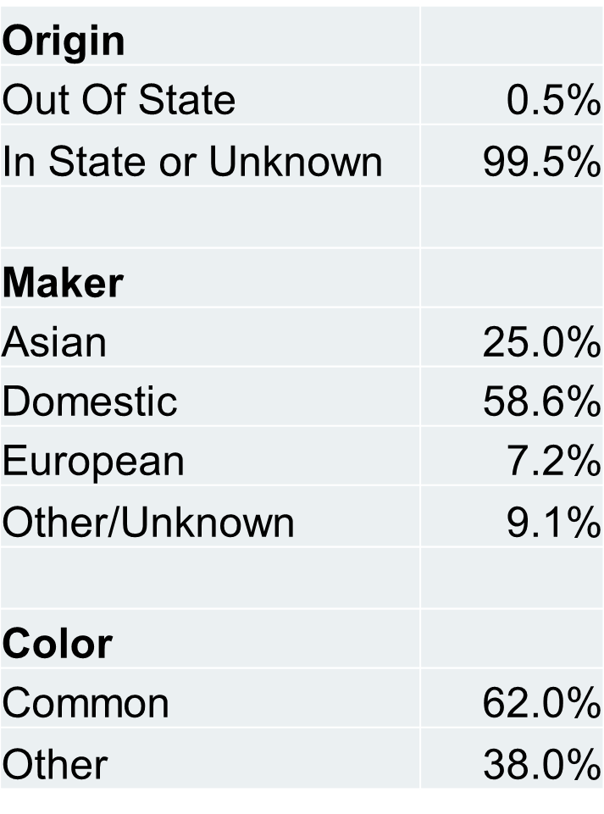

The hypothesis that all car characteristic variables are independent is shown to be false in Table 2. Analysis of Variance table for Independence of Loglinear model indicates that the color of the car and car origin are not independent with G-Squared = 349.84 (p <0.001).

Table 2. Relationship between the auto maker origin and the paint of the vehicle.

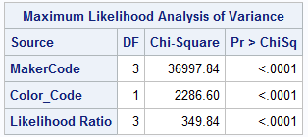

**Descriptives of the locations**

The next objective was to characterize where the vehicles were left. Most locations reported were side streets, so a possible explanation is that many vehicles were parked near the owner’s home or otherwise moved away from busier roads. The transit score values were clustered in the lower, or worse, ranges. Probably these areas also have more cars because the buses or trains are sparser or less frequent. These factors are summarized in Table 2.

Table 3. Characteristics of Locations

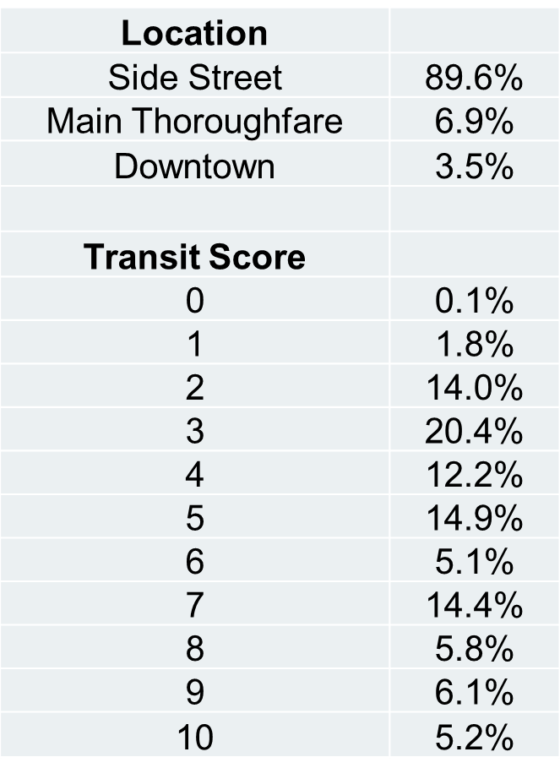

The duration of cases and reported park time are described in Table 3. The mean time of a complaint to full resolution is 19.7 days with a large standard deviation of 17.9 days. The skew in this case is 3.7, so the mean is an accurate average. This indicates that the average case is reported, investigated, and completed in less than 3 weeks, so this is a reasonable expected time for the city to address complaints.

Additional loglinear testing in Tables 4 and 5 shows further relationships between variables.

Table 4. Relationship between the manufacturer's origin and access to public transportation.

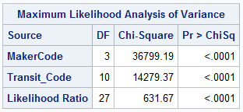

The Analysis of Variance table for Independence of Loglinear model shows that the transit score and car origin are not independent with G-Squared = 631.67 (p <0.001). The access to public transportation correlates to the type of car reported.

Table 5. Relationship between the state the license plate is registired in and where the car is left.

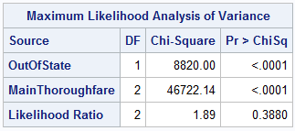

Using an Analysis of Variance table for Independence of Loglinear model, we do not have enough evidence to reject the null hypothesis that vehicles with out of state plates are abandoned in any particular type of street with G-Squared = 1.89 (p <0.388).

**Descriptives of the response**

To address the objective of modeling the city’s response, the response was compared with other variables.

The distribution of the days parked is wider, with a mean of 35.8 days and standard deviation of 57.7 days, with a large positive skew of 6.1. Those reporting abandoned cars are typically waiting over a month to call the complaints into the 311 service, though the city allows for shorter wait times.

Table 6. Duration of parked time and case in days.

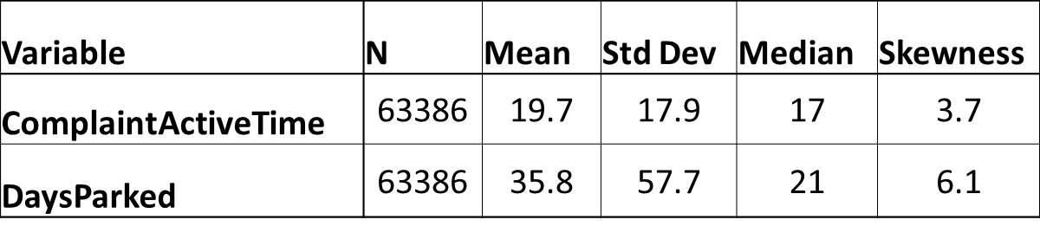

A chi-squared test was used to test the null hypothesis that response time was unrelated to the location of the vehicle. The chi-square result of 120.97 (df = 2, p < 0.0001) led to rejection of the null hypothesis. In particular, cars in downtown areas had a cell chi-sq 43.40 for less than 3 weeks and 64.67 for greater than 3 weeks, indicating that complaints are resolved faster in this area than would be expected if the variables were independent. This area is more expensive and populated, so abandoned cars are more noticeable and impact traffic, therefore city response is faster.

**Modeled Response**

Finally, the city response was modeled by examining multiple techniques. In each variation of the logistic regression (saturated and unsaturated with different combinations of variables and selections), the Hosmer and Lemeshow test returned low p-values, so this model was not found to be a good fit. However, the odds ratio estimates from the model provide a clue as to which values drive the city’s response time. As Table 7 shows, the color of the vehicle and the duration of its abandonment before it was reported are not expected to affect the city’s response time because the confidence limits include the value 1. However, the vehicle being from out of state, its location, and the make could be variables that affect the results.

Table 7. Odds Ratios based on logistic regression for variables affecting city response time.

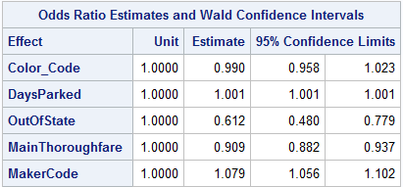

Using glm with a Poisson distribution and log link, the best fit is calculated as shown in Table 8. This model maximized log likelihood and had deviance closer to 1 (0.73) than a normal distribution. The negative binomial model was examined, but the dispersion was 0, so the Poisson distribution was thought to fit better. Though variable interactions were included in other versions, the p-values were greater than 0.05, so they were not deemed significant. Therefore, a fitting equation predicting whether city response time would be greater than 3 weeks is log(response) = -0.96 – 0.32 (Out of State) – 0.06 (Main Thoroughfare) + 0.05 (Maker).

The vehicles’ out of state plates caused a higher change in log count than the effect of the location of the vehicle and its manufacturing origin. The chi-squared analysis in the previous section shows that vehicles downtown are processed faster, so this explains the effect of location.

Table 8. Best fit for the prediction of city response time.

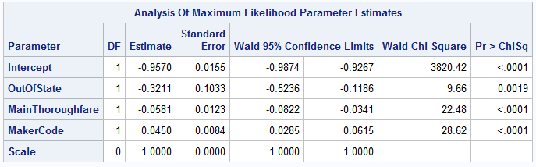

**Summary**

This analysis has shown that most abandoned vehicles are from Illinois or unlisted state, are domestic makes, and painted the common colors white, gray, black, silver, and red. The vehicles are likely to be older models, and left on side streets in areas with poor access to public transportation. The average complaint takes 19.7 days to resolve with a standard deviation of 17.9, and citizens are waiting more than a month to call in the complaints to 311. Chi-squared tests show a relationship between the type of manufacturer and color, and between the manufacturer and the ward’s access to public transportation. However, no relationship is shown between out of state vehicles and where they are parked. The city is more likely to resolve complaints in less than three weeks if the vehicles are parked downtown. Other factors that predict city response are whether the license plates are registered out of state and whether the maker is domestic, Asian, European, or unknown. A Poisson model provides the best fit, forming the equation predicting whether city response time would be greater than 3 weeks log(response) = -0.96 – 0.32 (Out of State) – 0.06 (Main Thoroughfare) + 0.05 (Maker).

**Conclusions**

The city’s response is relatively unbiased by the color of the vehicle. The influence of the out of state plates and maker could be explained by the owners’ speediness in picking up the car from tow or moving it as requested, because a complaint is not resolved until the vehicle reaches a final state. Possibly a person from another state would need to resolve the matter before leaving the city, or someone with a European car may have additional resources available to tow the car once a complaint is lodged. Therefore, a separate reporting variable is suggested so the city’s response may be divorced from influence by the owner of the vehicle. In other words, it would be useful to determine how long it takes for the city to take the first action in the case in addition to examining how quickly cases are closed.

Additionally, the location of the vehicle affects response but not the transit score. As shown, this is due to the necessity of quickly relocating vehicles in high-density downtown areas. The city appears to be unbiased in dealing with wards of different transportation profiles.

**Limitations**

If the data were more reliable, the analysis could better characterize the abandoned cars in Chicago. No year or model was reported for the vehicles, and many values were absent. Some days parked values were negative or meaninglessly high. As well, it would be useful to know what the actual state of the car was, whether it was damaged, in obvious disrepair, or had simply been left for a long period.

**Recommendations**

For future studies, a comparison of Chicago to its suburbs may offer additional insight in how the city handles abandoned cars as opposed to its lower density neighbors. Additionally, duplicates in the data should be analyzed to determine whether a higher number of complaints help speed the response.

Finally, public or private assistance could mitigate the problem itself. Funding for emergency repairs and tows could help resolve issues before the citizens bring them to the city’s attention. Alternately or as a complement, improvement in transit access for the more isolated wards can cut down on the need to have vehicles.

# Works Cited

|  |  |
| --- | --- |
| [1] | C. Lutz, "The U.S. car colossus and the production," *Journal of the American Ethnological Society,* vol. 41, no. 2, pp. 232-245, 2014. |
| [2] | "How used cars are holding up.," *Consumer Reports,* vol. 74, no. 4, pp. 84-85, Apr2009. |
| [3] | P. Nieuwenhuis, "From banger to classic – a model for sustainable," *International Journal of Consumer Studies,* vol. 32, pp. 648-655, 2008. |
| [4] | K. H. Forslind, "The economics of environmental law enforcement:," *Eur J Law Econ,* no. 23, pp. 223-236, 2007. |
| [5] | "Abandoned vehicles in decline thanks to scrap prices, fines.," *BioCycle,* vol. 38, no. 3, p. 14, Mar1997. |
| [6] | "City of Chicago Data Portal," [Online]. Available: https://data.cityofchicago.org/Service-Requests/311-Service-Requests-Abandoned-Vehicles/3c9v-pnva. [Accessed March 2016]. |
| [7] | Mark Silvey, "Automotive Color Trends 2014," PPG Industries, Inc., 2014. [Online]. Available: http://newsroom.ppg.com/autocolor14. [Accessed March 2016]. |
| [8] | Q. Ford, "DNAinfo," 13 06 2014. [Online]. Available: https://www.dnainfo.com/chicago/20140613/downtown/cta-service-varies-widely-among-city-neighborhoods-study-finds. [Accessed March 2016]. |
| [9] | B. Vandervoort, "Chicago Transit & Railfan," [Online]. Available: http://www.chicagorailfan.com/majorst.html . [Accessed March 2016]. |
| [10] | M. Glynn, "Domestic or import car? Automakers blur lines with production sites," The Buffalo News, 25 January 2015. [Online]. Available: http://www.buffalonews.com/business/prospectus/domestic-or-import-car-automakers-blur-lines-with-production-sites-20150125. [Accessed March 2016]. |

**SAS code**

*Note: Code used in the examination of data, but not final modelling, is also included here to demonstrate other avenues that were examined before choosing best fit*

ods graphics on;

ods rtf file = 'AbandonedCars.rtf';

**proc** **means** data = work.cars maxdec = **1**;

class OutOfState;

**run**;

**proc** **means** data = work.cars maxdec = **1**;

class MakerCode;

**run**;

**proc** **means** data = work.cars maxdec = **1**;

class Color_Code;

**run**;

**proc** **means** data = work.cars maxdec = **1**;

class ActionCode;

**run**;

**proc** **means** data = work.cars maxdec = **1**;

class MainThoroughfare;

**run**;

**proc** **means** data = work.cars maxdec = **1**;

class Transit_Code;

**run**;

**proc** **means** data = work.cars n mean stddev median maxdec = **1** skew;

var ComplaintActiveTime DaysParked;

**run**;

**proc** **freq** data = work.cars;

Tables MakerCode OutOfState Color_Code MakerCode*OutOfState OutOfState*Color_Code MakerCode*Color_Code / nocum chisq expected cellchi2 riskdiff cmh1;

**run**;

**proc** **freq** data = work.cars;

Tables ActionCode*Transit_Code /chisq cmh1 trend;

**run**;

**proc** **genmod** data = work.cars;

model ComplaintActiveTime = Color_Code DaysParked Transit_Code OutOfState MainThoroughfare MakerCode/ dist = poi link = identity;

**run**;

**proc** **genmod** data = work.cars;

model ComplaintActiveTime = Color_Code DaysParked Transit_Code OutOfState MainThoroughfare MakerCode/ dist = poi link = log;

**run**;

**proc** **genmod** data = work.cars;

model ComplaintActiveTime = Color_Code DaysParked Transit_Code OutOfState MainThoroughfare MakerCode/ dist = negbin link = log;

**run**;

**proc** **logistic** descending data = work.cars;

model ComplaintActiveTime = Color_Code DaysParked Transit_Code OutOfState MainThoroughfare MakerCode;

**run**;

**proc** **logistic** descending data = work.cars;

model ComplaintActiveTime = Color_Code DaysParked Transit_Code OutOfState MainThoroughfare MakerCode/selection = forward details lackfit;

**run**;

**proc** **logistic** descending data = work.cars;

model ComplaintActiveTime = Color_Code DaysParked Transit_Code OutOfState MainThoroughfare MakerCode/ctable pprob = (**0** to **1** by **.1**) lackfit risklimits;

**run**;

**proc** **logistic** descending data = work.cars;

model ComplaintActiveTime = Color_Code DaysParked OutOfState MainThoroughfare MakerCode;

units How_Many_Days_Has_the_Vehicle_Be = **7**;

**run**;

**proc** **logistic** descending data = work.cars;

model ComplaintActiveTime = Color_Code How_Many_Days_Has_the_Vehicle_Be Transit_Code OutOfState MainThoroughfare MakerCode

DaysParked*Transit_Code DaysParked*Color_Code DaysParked*OutOfState DaysParked*MainThoroughfare

Color_Code * Transit_Code Color_Code*OutOfState Color_Code*MainThoroughfare

Transit_Code*OutOfState Transit_Code*MainThoroughfare OutOfState*MainThoroughfare

MakerCode * Color_Code MakerCode*Transit_Code MakerCode*OutOfState MakerCode*MainThoroughfare MakerCode*DaysParked

/selection = forward include = **3** details lackfit;

**run**;

**proc** **logistic** descending data = work.cars;

Class Color_code OutOfState MainThoroughfare MakerCode;

model ComplaintActiveTime = Color_Code MakerCode DaysParked Transit_Code OutOfState MainThoroughfare/ selection=backward lackfit;

**run**;

**proc** **catmod** data = work.cars;

model Vehicle_Code*Color_Code=_response_ / noiter;

loglin Vehicle_Code|Color_Code;

**run**;

**proc** **catmod** data = work.cars;

model MakerCode*Color_Code=_response_ / noiter;

loglin MakerCode Color_Code;

**run**;

**proc** **catmod** data = work.cars;

model OutOfState*MainThoroughfare=_response_ / noiter;

loglin OutOfState|MainThoroughfare;

**run**;

**proc** **catmod** data = work.cars;

model MakerCode*Transit_Code=_response_ / noiter;

loglin MakerCode|Transit_Code;

**run**;

ods graphics off;

ods rtf close;

**run**;